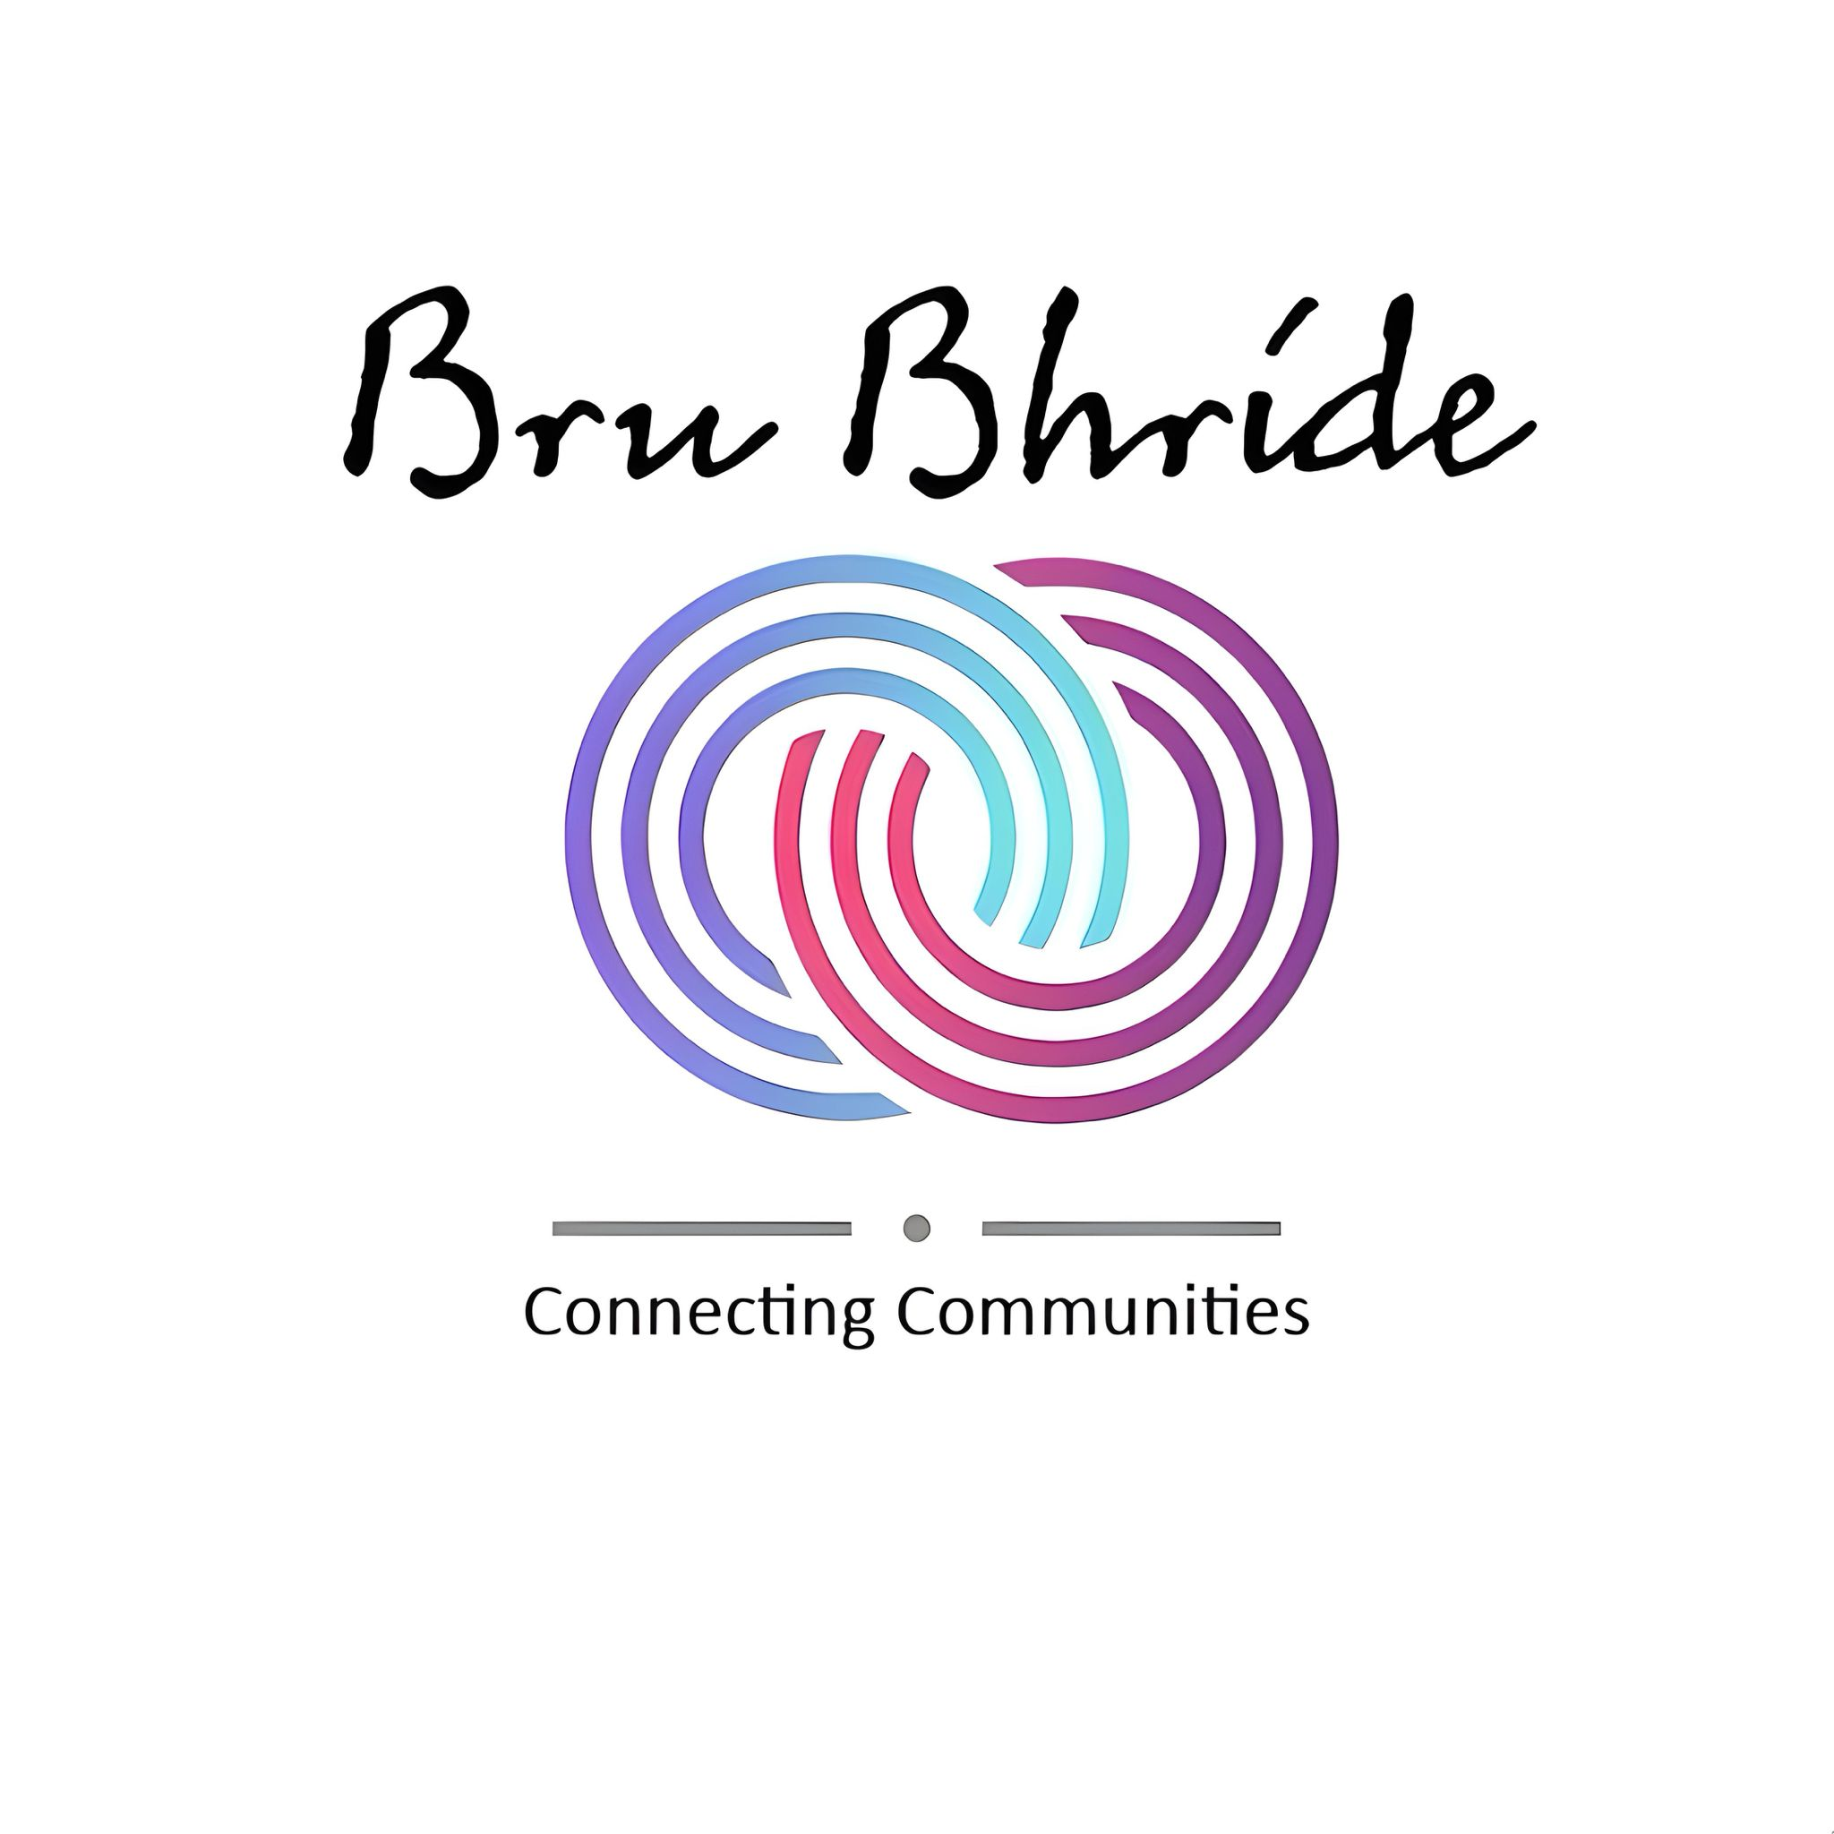
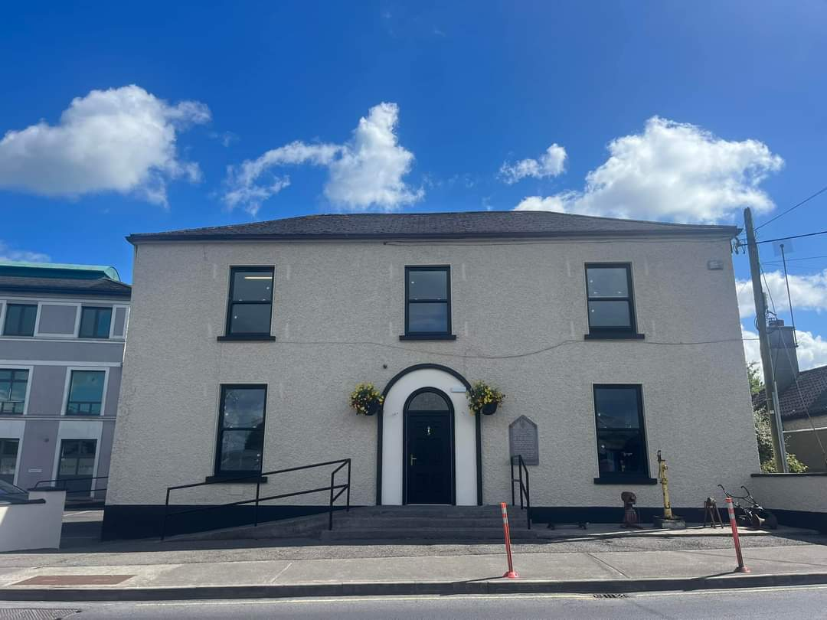
  - COMMUNITY SERVICE PROGRAMME

Welcome to the first Newsletter of the Community Service Programme which is a quarterly Newsletter designed to capture and record some of the wonderful initiatives taking place in Bru-Bhride Tuam.

In this edition we are focusing on some of the changes to Bru-Bhride, and sharing a sample of some of the wonderful activities that are taking place WITHIN THE ORGANISATION. Thanks to all the STAFF for their good work and allowing us to share all that is happening.

Bru-Bhride has undergone major refurbishment both inside and outside the building
Did you know we have many spaces and rooms available to rent ? No matter what your age group is we have a room to fit your needs.
Pop us an email on admin@westtrav.ie or give us a call or text on 087 7022187
to discuss our competitive room rental rates.

We are a new project and we began in April/ May of this year.

Community Service Programme staff is led by Emilie Galvin Manager, Caroline Connor & Ciara Ward Administrators and John Ward & Deirdre Ward Caretakers.
We are funded by POBAL.
We are located in the offices upstairs In Bru Bhride.
The CSP supports us to provide employment opportunities to target groups (Migrants, Traveller etc).
CSP encourages self-sustainability which we have been doing, (we encourage recycling in the building, limited our waste, our buildings energy efficiency was recently hugely reduced through retro-fit & our paint reuse project).
Our team is currently carrying out work on the allotments. David received funding from GRD so we hope they will be in great condition for 2025 for the public. Spread the word on this also please.
We are also over the Bru Bhride Social media page and Bru Bhride website which is currently being updated. If you have updates or information on your projects please send them on to us to share on our platforms.
We are funded to address the needs of the local community. We are currently doing so by providing spaces and rooms to the community at an affordable rate as there is limited spaces available at the moment in Tuam.

Strategic Principles of Community Service Programme are:

To address community needs through supporting services and community assets ensuring these are inclusive and responsive to those experiencing disadvantage or marginalization.

To provide employment opportunities and improve the employability of individuals most distant from the labour market/or in disadvantaged areas.

To strengthen and support community organisations operating as social enterprises to deliver improved facilities and services and to pilot innovative social economy initiatives.

Horizontal Principles

Social Inclusion and Equality
Building Sustainable Communities

The CSP currently supports over 420 community-basesd organisations in Ireland.

We said farewell to Erin Conway in July as she returns to teaching. Erin has worked with us in our Star Programme for the past five years as Home School Liaison Co-ordinator. Erin will be dearly missed by us all but we wish her well in returning to her teaching post.

Bridget Marie Ward has also finished on the Star programme August where she has worked for the past five years, she still remains with us as our Sasta Cena peer project worker and takes up this at the end of August.

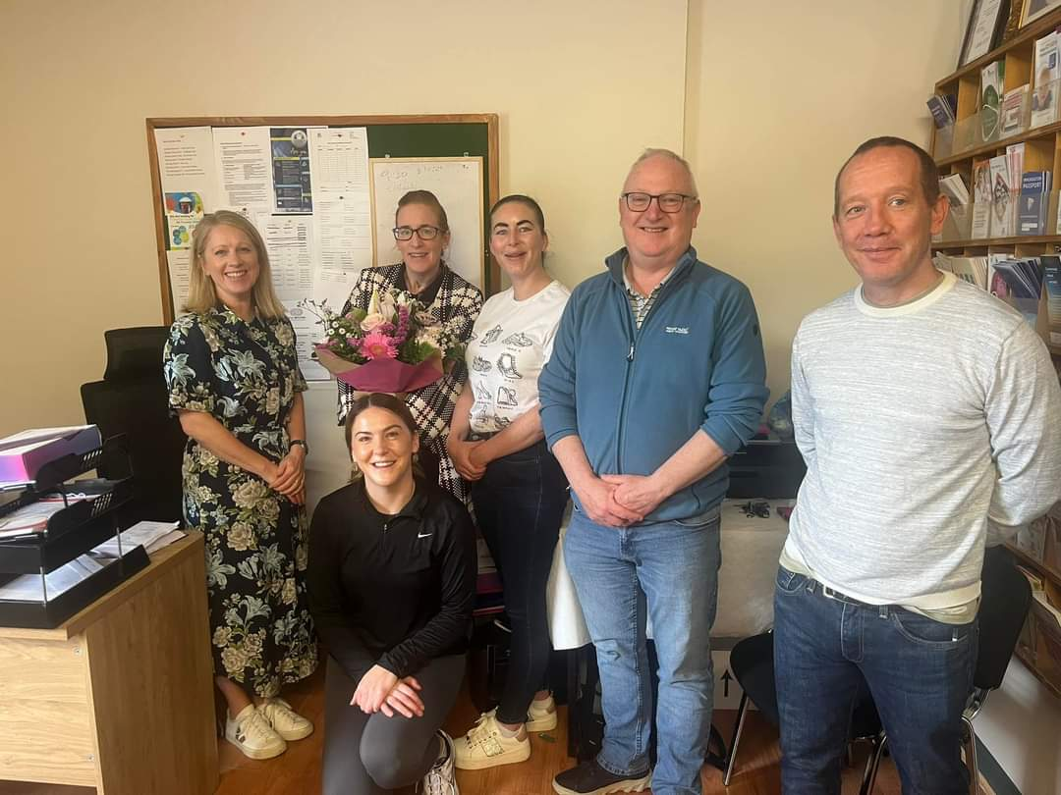

We welcome Siobhan Barret who will be taking up the position of Home School Liaison Co-ordiantor with Star and to Martin F Ward and Arianna Ward on their new positions as Education Workers.

Youth Mental Health First Aid: MHFA Ireland in conjunction with St. John of God’s Hospital held a 2 day workshop in Bru-Bhride in August, 19 people participated in this workshop, this included 9 workers from our own organisation. The training looked at how to best recognise and support the mental health of our young people, and to increase our awareness and our willingness to address mental health problems when they arise. 6 of our Youth worker’s also completed this training in July 2024.

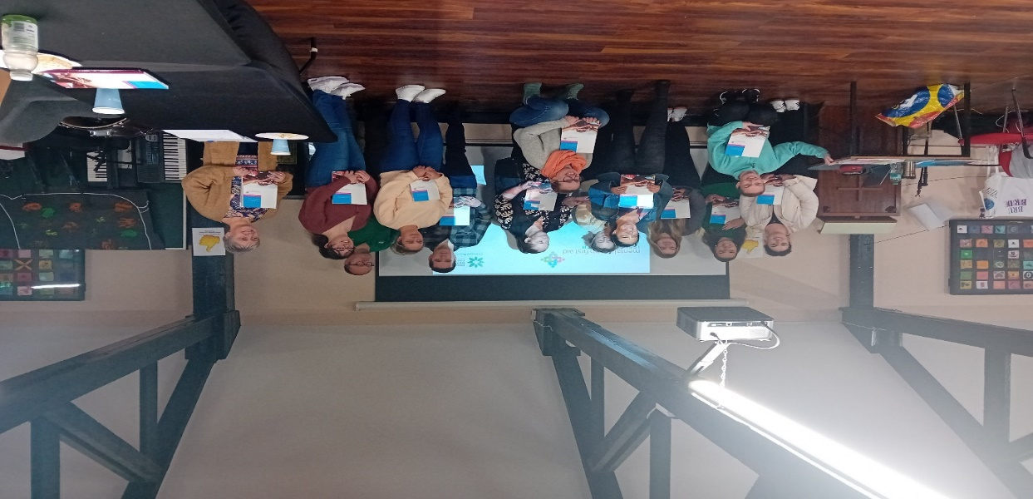

What We Do
Bru-Bhride Youth Project
Martin Ward is the Youth Project Co-ordinator and he has organised various weekly and annual events such as:
- Monday Club based in Parkmore Community House
- Tuesday Club based in Harmony Hall
- Wednesday club based in Harmony
- Saturday Group based in Parkmore Area
- Music Generation
- Arts Hubs
- Christmas craft fair
- Men’s Shed
- Summer Activity Programmes
- Traveller Pride Week
- Open Mic
- Community Radio

For further information you can contact Martin at Bru-Bhride

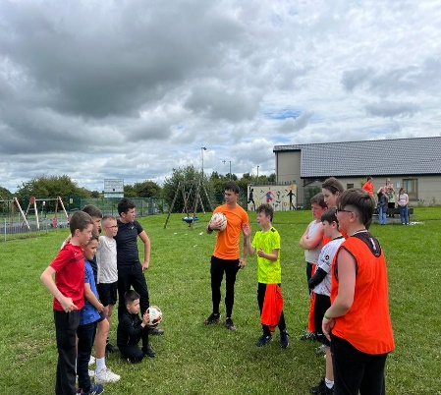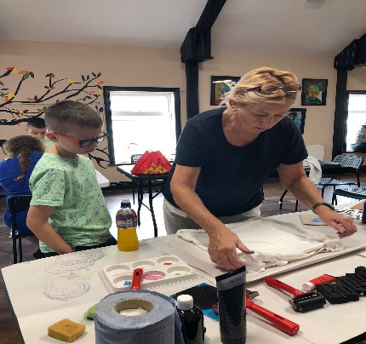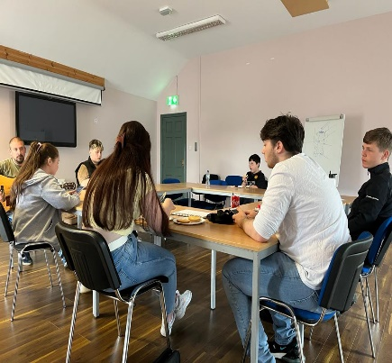
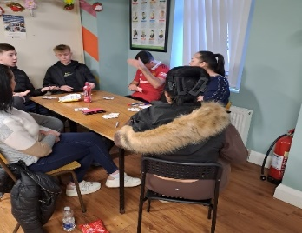
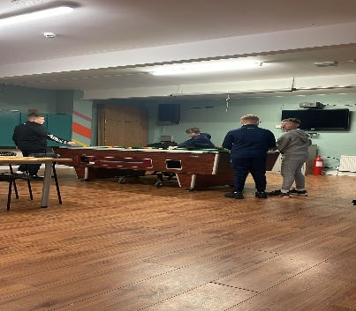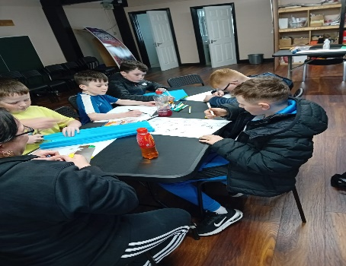

Star Tuam

Star is made up of four staff members Paul Hayes, Martin F Ward, Arianna Ward are Education Workers,Siobhain Barett is a Home school Liaison Co-ordinator. Star aims to improve the attendance, participation and retention of Traveller children and young people in school in the Tuam area.

Areas of work include:
- Student mentoring
- Star Academy – Life Skills
- Individual support for families, pre-school, transition, attendance, mentoring, work experience, third level.
- Group activities
- Day trips
- Music
- Wilderness Programme
- TPS 6th class Transition Programme
- Art Programmes
- Social Media page
- Awareness campaigns - school attendance, pre-school education.
- Engaging with community services and groups

For further information on Star call to Bru-Bhride

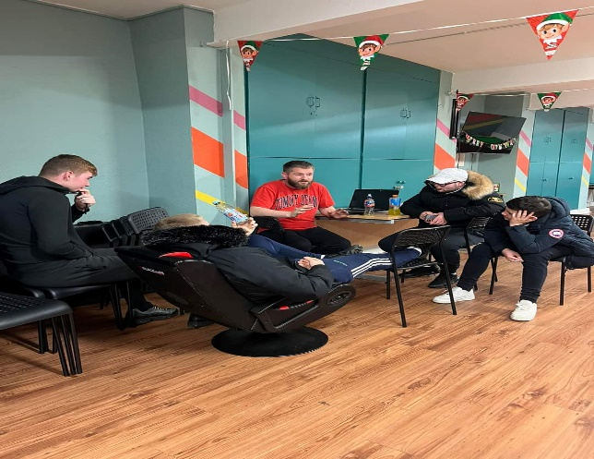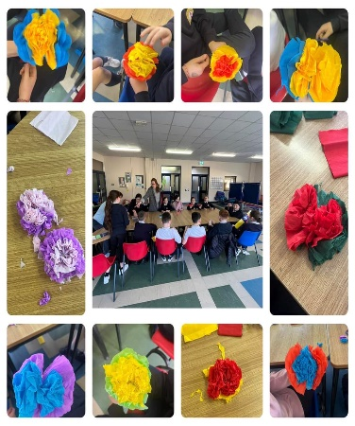
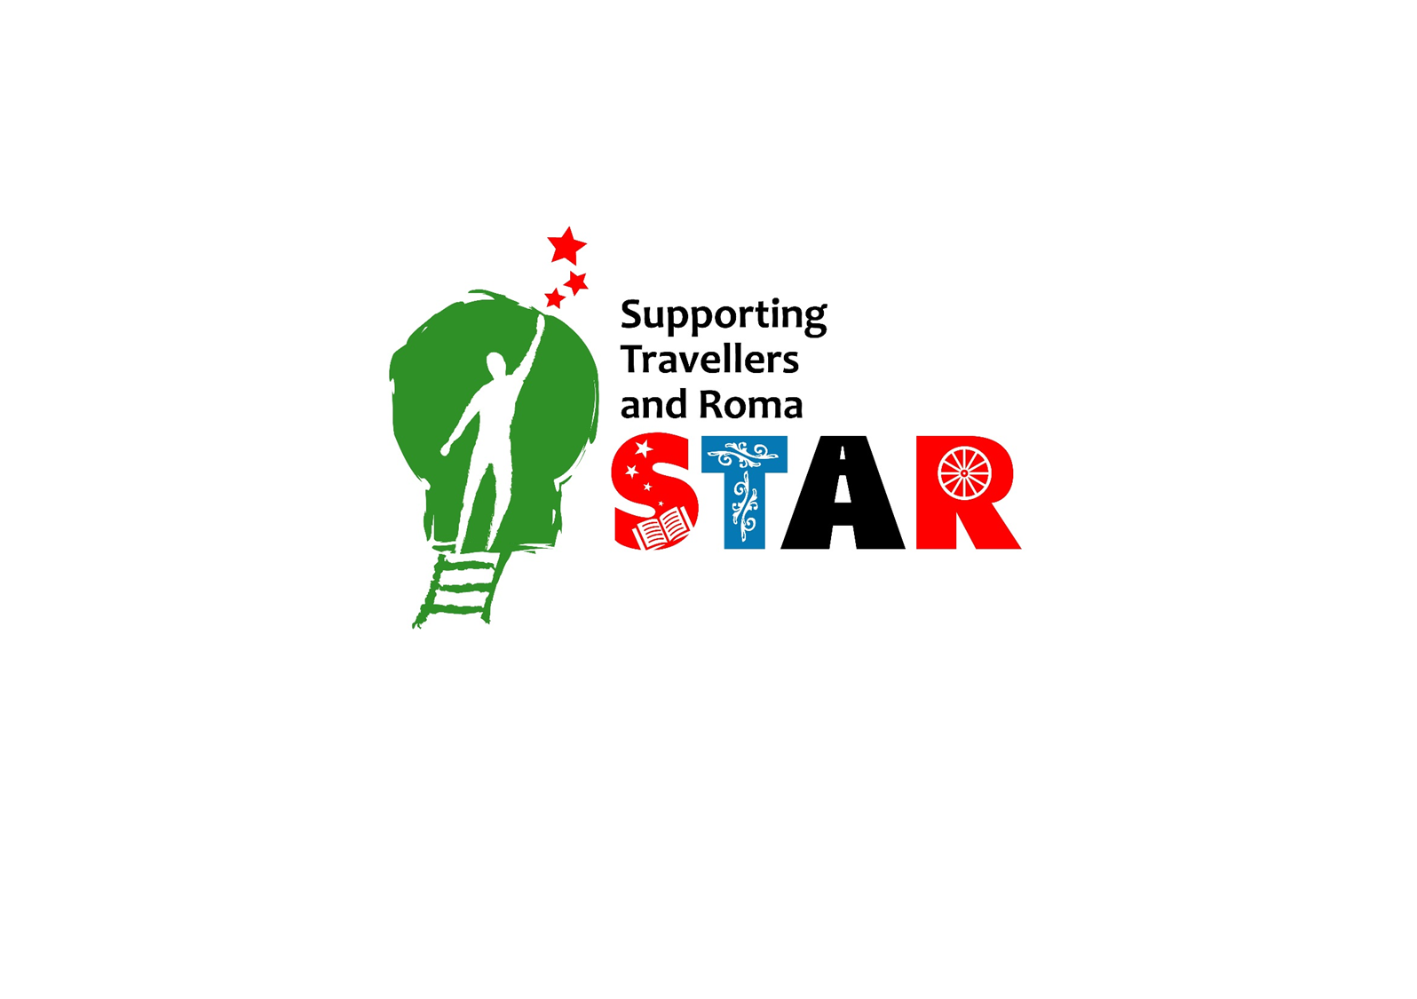

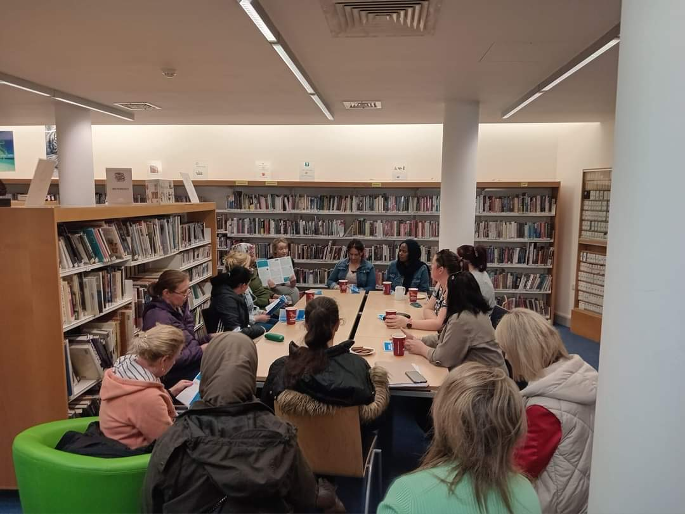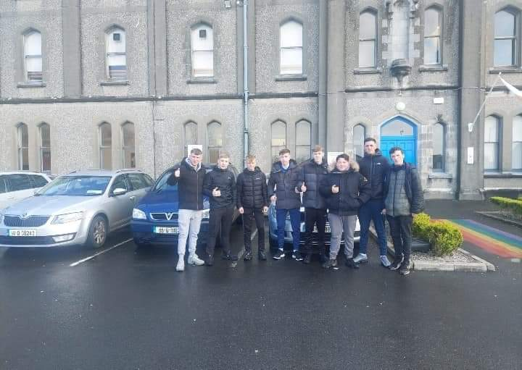

Where to from here:
- Continued Student and Parental support.

- Work with young people to devise a plan of activities that they are interested in.

- Promotion of education and training on offer through local services.

- Attendance clinics.

- Homework Support.

- Individual Case Plans – Work with Schools to look at case needs.

Primary Health Care 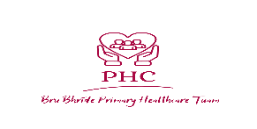
Kathleen Ward is the fulltime Primary Health Care Co-ordinator and leads a team including Mary Ward who is a fulltime Community Health Worker and ten parttime Community Health workers. Three of the parttime community health workers also work as a Wellbeing Worker and as support workers for Sasta Ceanna.
The team work on the following:
- Health Promotion
- OutreachWork which includes cervical check,breast check, child development & immunisation, healthy heart, mental health awareness, diabetic screening, cancer awareness, suicide awareness,asthma and wellness in pregnancy, distributing pregnancy care packs, sanitary packs, food cloud, ppe such as hand sanitisers and gloves
- Various Health Information Workshops during the year
- Creative Women’s Group
- Men’s Health
For further information you can contact Kathleen at Bru-Bhride.
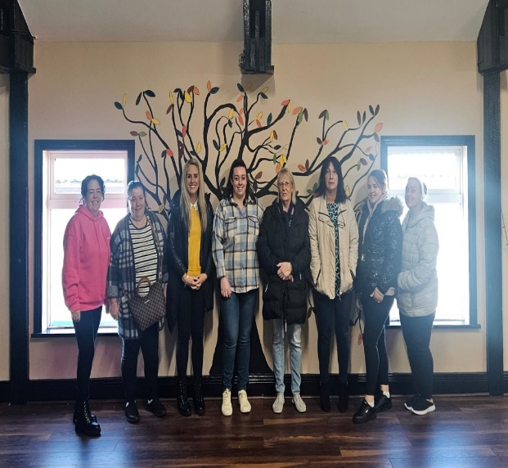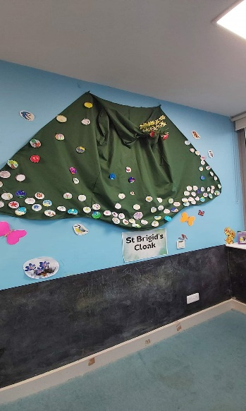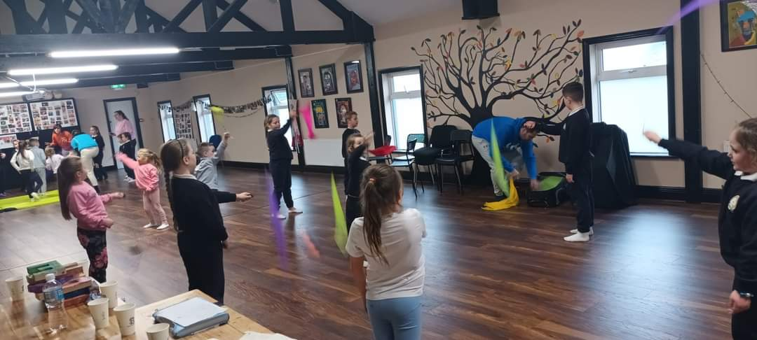

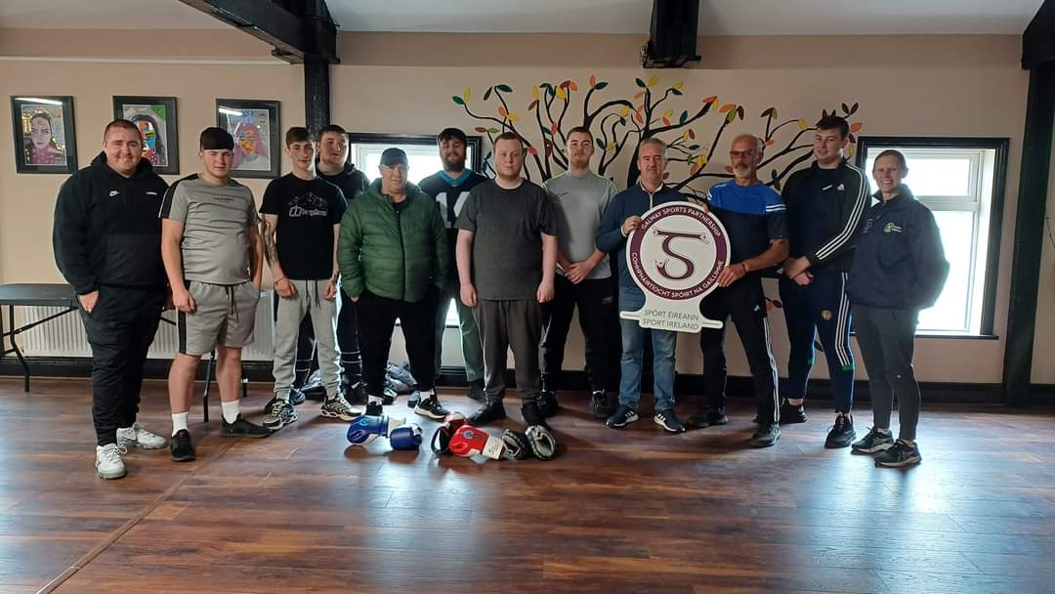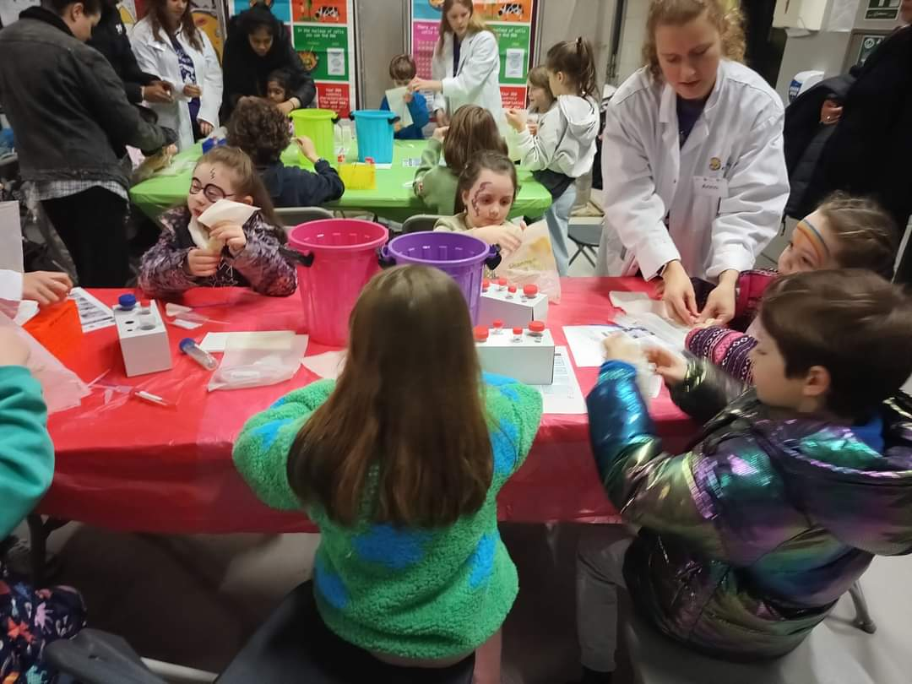
Tuam Community Childcare Centre

"We are a community service organization managed by a Board of Directors that oversees the operation of our services."
Under the Board of directors are:

- Manager
- Deputy
- Linc coordinator
- Lead educators
- Educator
- Bus driver
- Kitchen chef

Tuam Community Childcare Centre is based in Parkmore Estate with Louise O’Shaughnessy as Manager, Mary Ward Deputy Manager , Sandra Mills Deputy Manager and a staff of 16 childcare workers.

The service is registered with Tusla and offer the ECCE Scheme which runs for 38 weeks and the National
Childcare Scheme runs 46 weeks of the year. The service operates from Monday to Friday from 9 a.m. to 6.30 p.m daily.

Our Early Childcare Educators:

- Garda Vetted
- BA (Hon) Early Childhood Care & Education ( Level 8)
- BA (Ord) Early Childhood Care & Education ( Level 7)
- Qualified in Early Childhood Education (Level 6)
- Cert in Early Learning & Care (Level 5)
- LINC Inclusion Co-ordinator’s
- SNA (Special Needs Assistance) (Level 6)
- First Aid Response
- Children First
- Fire Safety
- Food Safety HACCP

For further information you can contact Louise at the Childcare Centre in Parkmore @ 087 7022492

Tuam Community Childcare Centre
Parkmore Estate, Tuam, Co Galway H54 V663
093 28440 / 0877022492

Sasta Cena (Secure, Accessible, Safe, Traveller Accommodation) is led by Bridget Marie Ward and supported by Tereasa Donoghue and Mary Teresa Ward.

The role of the project workers will be to establish a homeless support pilot project for a period of 18 Months for Traveller women to work alongside the primary healthcare projects for Travellers in Tuam and Galway city, starting August 2024.

The project is funded by Genio and the HSE

The project will work from a community development and Human Rights approach.

The project workers role will include the following tasks:
- Develop a work plan for the Sasta Cena Project
- Establish a forum in Galway to facilitate partnership working between agencies who have a role in addressing Traveller homelessness
- Establish the health and accommodation needs of Traveller women who are homeless or at risk of homelessness
- Provide an outreach health and accommodation information and signposting services to Traveller women who are homeless or at risk of homelessness
- Advocate for equality outcomes for Traveller women & their families in relation to their accommodation and health needs
- Identify specific challenges facing Traveller women to engage in health services as a result of their accommodation status such as missed appointments and develop a response to address this by liaising with health service providers
- Identify the additional impacts of homelessness on the families of women in particular school attendance, child development delays and work in partnership with other relevant agencies to develop solutions to lessen the impact.
- Provide cultural competency training for agencies working with homeless Traveller women to improve the service delivered to the women
- Engage with services working with Traveller women at risk of homeless in particular Women’s refuge, prison and probation services and The Galway Housing First Pilot project
- Report writing and evaluation
- Link with research partners to support research into the needs of Traveller women who are experiencing or who are at risk of homelessness
- Develop working relationships with agencies who have a role in health and accommodation needs of Traveller women and their families including the Local Authorities, COPE, The Simon Community, Domestic and Gender based violence services, social housing agencies, Traveller Justice Initiative, Community Law and Mediation Service, Probation services, mental health, primary care and disability services

Organisations & Clubs based in our premises

Citizen’s Information Services Tuesday 10am -1pm 2pm – 4.30 pm
( Down Stairs in the main building) Wednesday and Thursday 10am – 1pm
Seetec Employment Services Monday - Friday 9am – 5pm
(Upstairs in the main building)
Failte Isteach Tuesday 10am-12.30 am
(Harmony Hall) Wednesday 7pm-8.30 pm
Alcoholics Anonymous Monday, Wednesday, Friday 1pm-2pm
(The Den) Thursday 8pm – 9pm
Narcotics Anonymous Friday 8-9pm
(Harmony Hall)
Sahanna Dance Group Thursday 6pm-7pm
(Harmony Hall)
Gambler’s Anonymous Wednesday 8-9 pm
(The Den)
Family Carer’s Ireland Last Friday of every month
( Harmony Hall)
Simon Community
Parkmore House,
Parkmore Estate, Tuam
Clients are met on an appointment basis.
Anyone seeking an appointment should contact the following number: 0909 61634

Upcoming classes for September 2024 will include a six programmes in yoga, pilates, sewing/upcycling

Below is a small selection of photographs depicting some of whats happening here in Bru Bhride

The Community Bus is been renovated at the moment, the bus will be used to hold activities with young people in Parkmore.
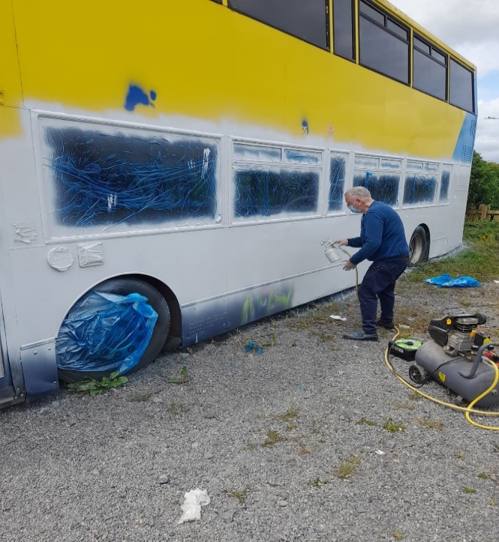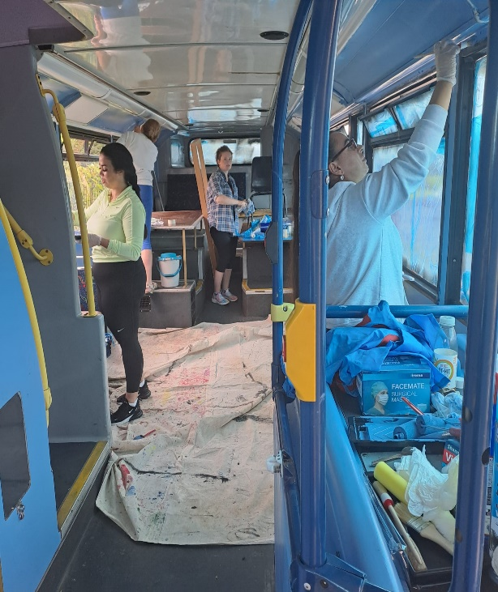

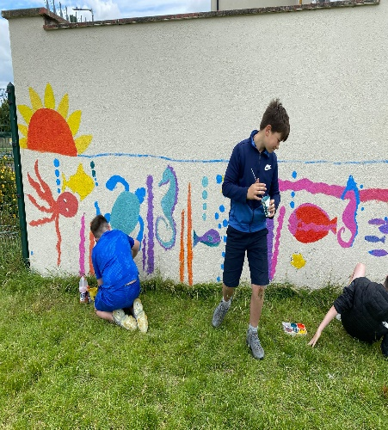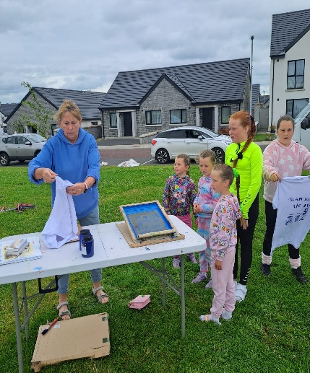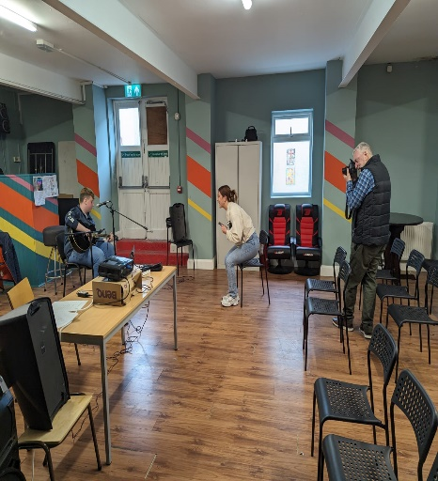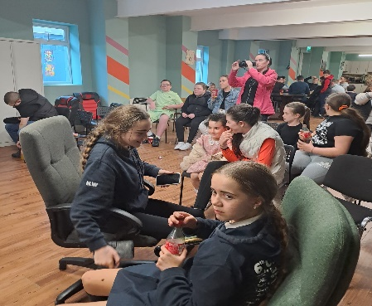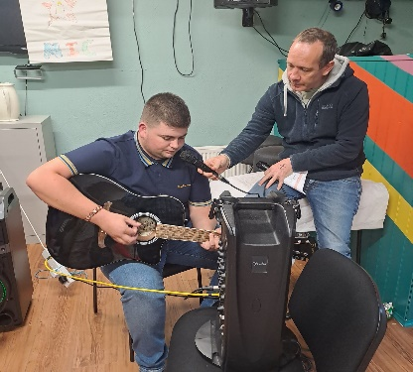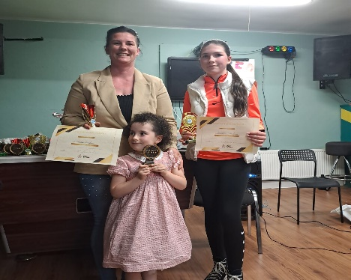
A selection of some of the fantastic woodwork that is been made here in Bru-Bhride

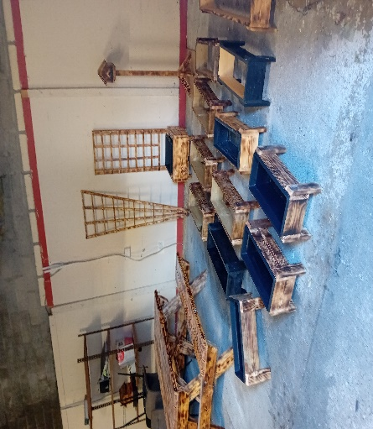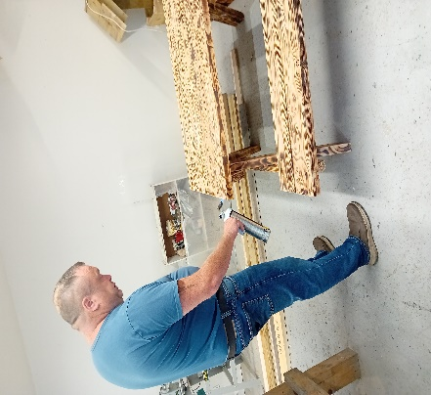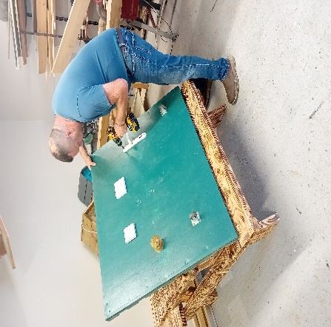
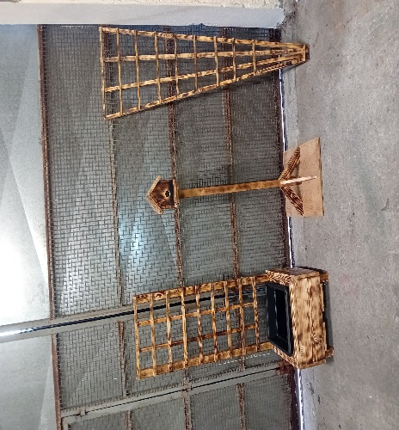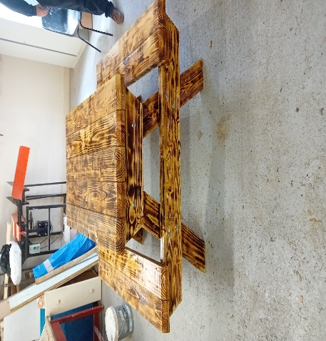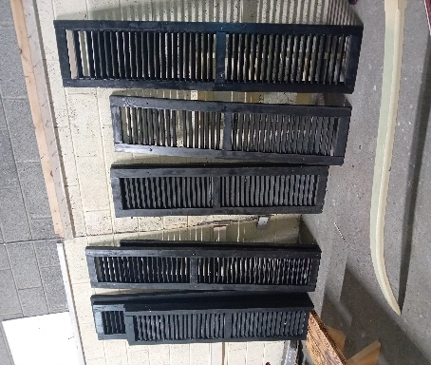

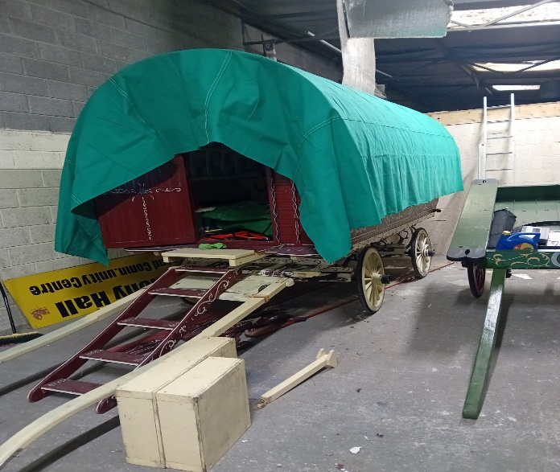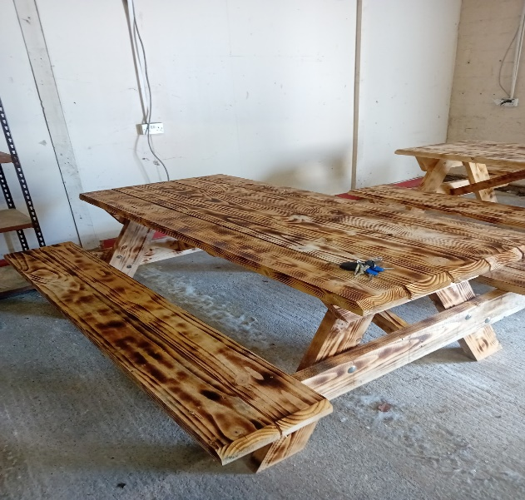
New cover been put on wagon

Tuam Community Radio

Tuam Community Radio/Podcast was launched on the 6th of June and can be found on Spotify and followed on Facebook. Martin Ward, Martin, Joe & Jason look after the podcast on Spotify, which looks the history of Tuam, times past, old traditional songs and stories that have been collected over the years by Travellers and those from the settled community who have since passed away and local events. Work is ongoing in developing further podcasts.

Kathleen Keenan launched her CD Beautiful Angels on the 6th of June with special guests Leo Moran and Padraic Stevens. A great night of traditional songs were sung by Kathleen , her father Jimmy, Brother Davy and his wife Annie.
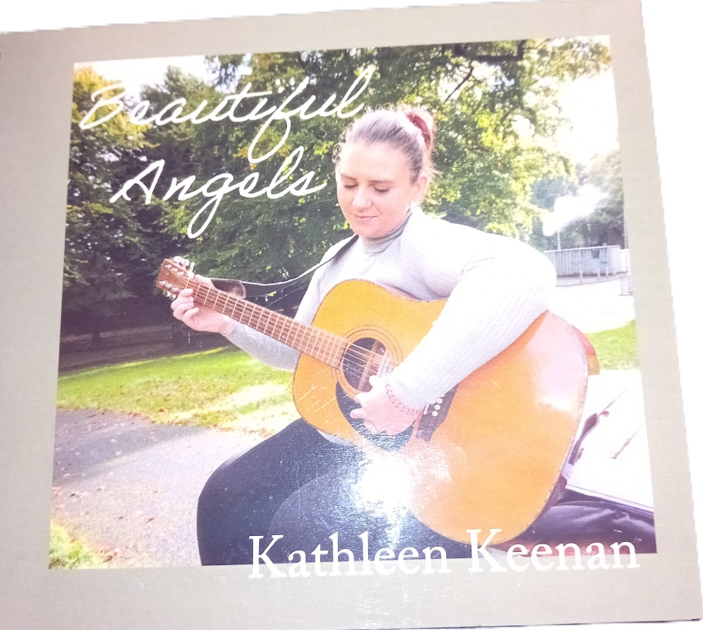

A staff day was held on Wednesday the 28th of August in Bru-Bhride, where each of our projects gave a presentation on the work they do. It finished of with a great session with Martina Passman who is our resident artist.
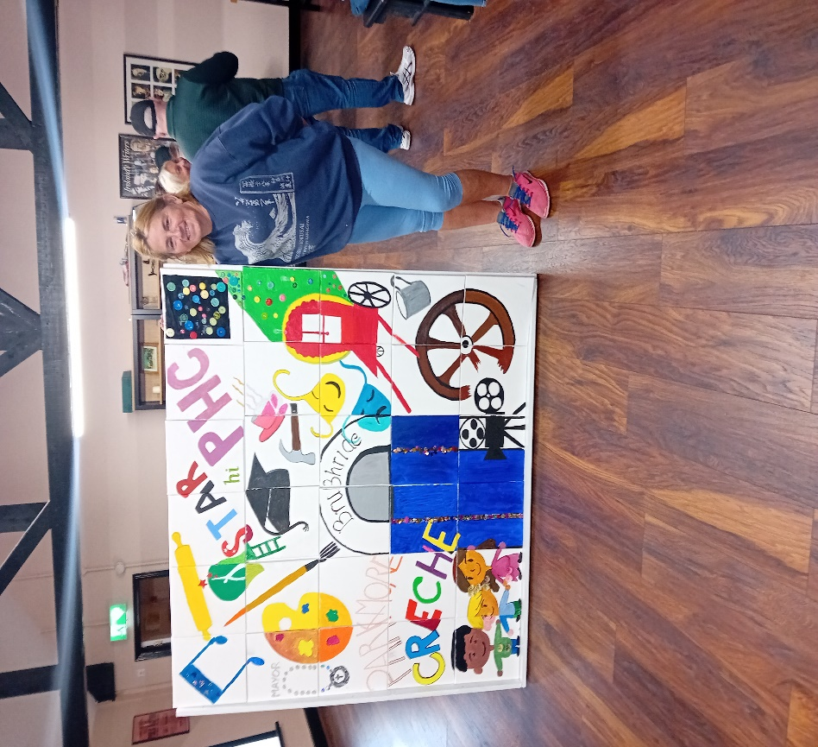
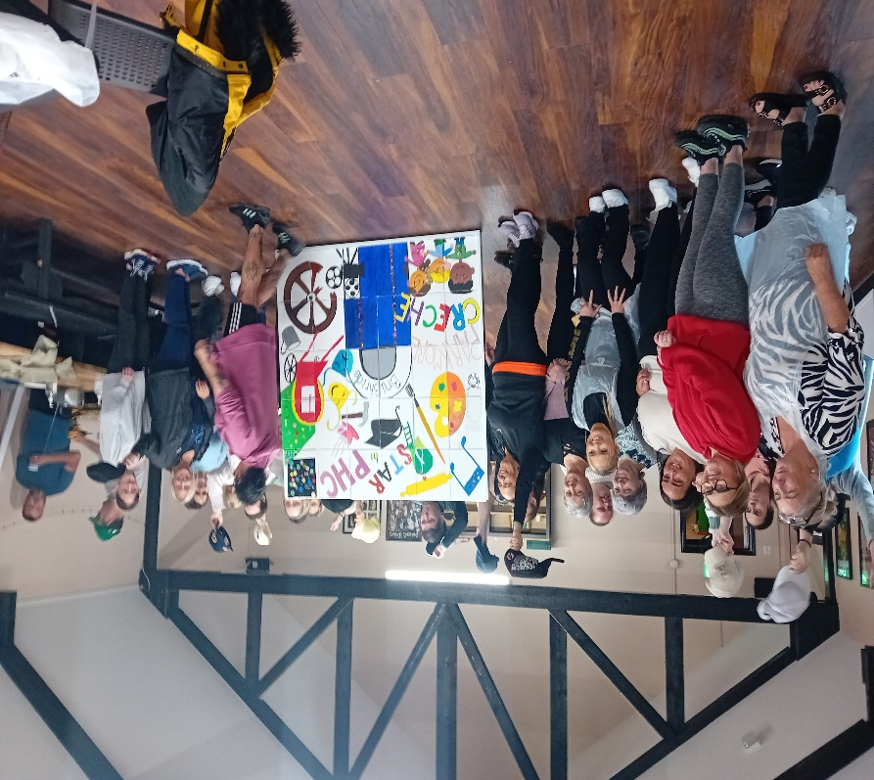

Please join us on Cultural Night at our Open Mic Session

In Harmony Hall

Please Join our PHC Project in Tuam library on Culture night on Friday the 20th September from 4.30pm to 7pm

A display and demonstration on Beady Pockets will be held by our talented staff. This event is open to all. Light refreshments will be available.

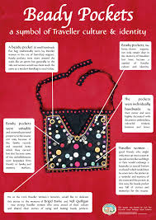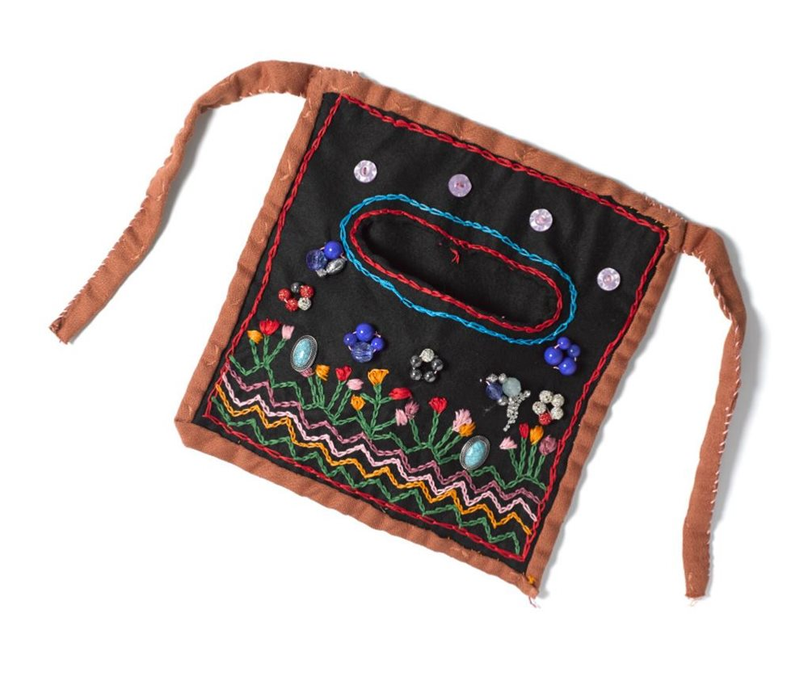

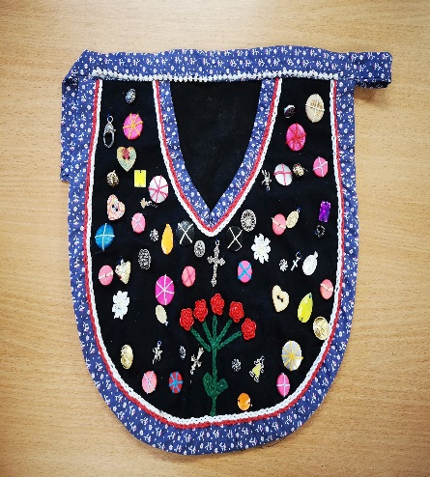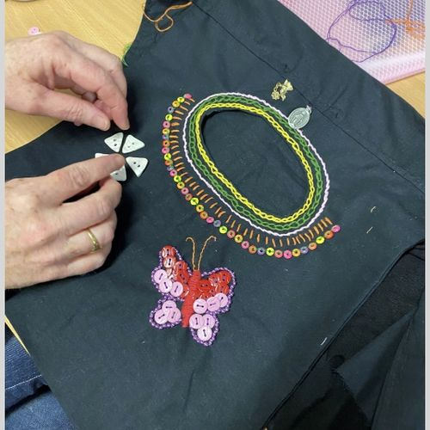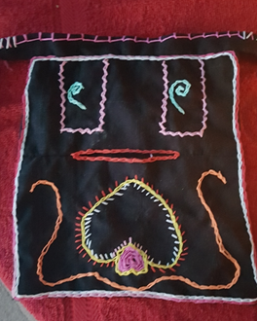

To register for activities and club membership please call to Bru-Bhride.

Limited spaces available

Registration for Music Generation now taking place

  - BRU BHRIDE YOUTH PROJECT
  Venue: Harmony Hall  Time: 3- 4.30 pm  Age Group: 10-12 years only  Time: 4.30 – 6 pm  Age Group: 13 years plus  Arts Programme from 4pm  With Martina Passman  Tuesday Club | Venue: Harmony Hall  Time: 4 – 7pm  Age Group: Strictly 13 years and over  Music Generation Programme  (Every Wednesday during school term)  Venue: Heritage Room  Time: 3.45pm-6pm  Age Group: 10 – 18 years  Wednesday Club

Bru- Bhride Primary Health Care and Star Project attended the Make the Link Event held in Tuam on the 6th September that was hosted by GRETB, GRP AND DSP.

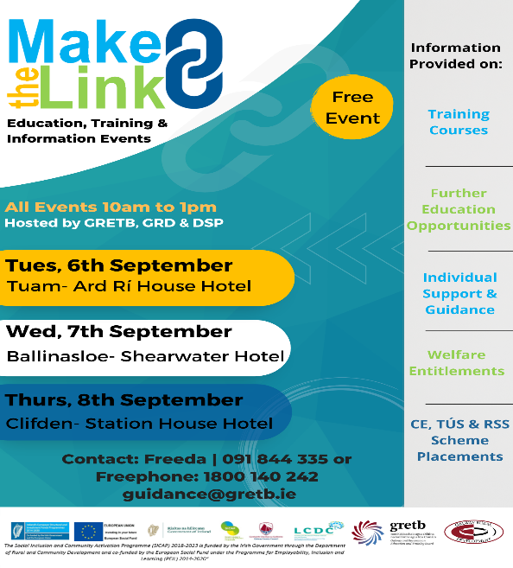
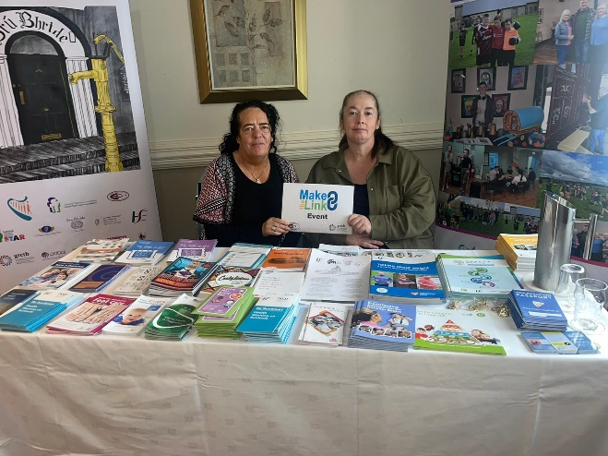

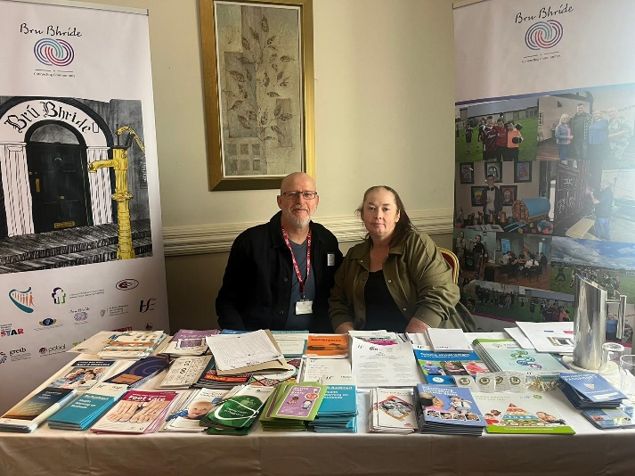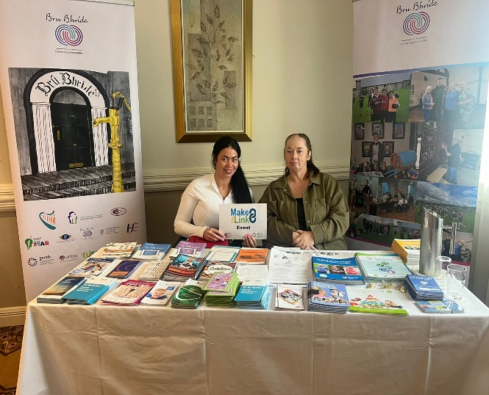

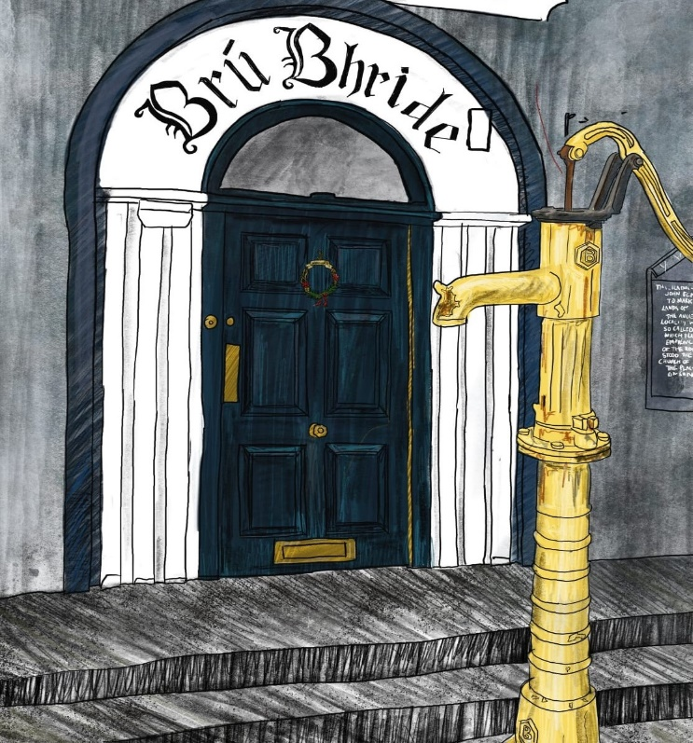

Pobal administers and manages Government and EU funding

to address disadvantage and support social inclusion

